Evidence of Evolution

**Background**

When Charles Darwin first proposed the idea that all new species descend from an ancestor, he performed an exhaustive amount of research to provide as much evidence as possible. Today, the major pieces of evidence for this theory can be broken down into the fossil record, embryology, comparative anatomy and molecular biology.

**Fossils**

The fossil record for the ancestors of the modern horse is one of the most complete records.

The picture below shows the evolutionary progression of the horse, from its ancestor, Eohippus, to the modern horse, Equus.

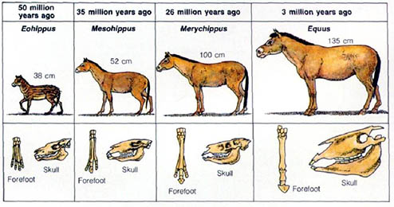

Describe how the forefoot and the skull has changed over time.

Over time, how has the size changed from Eohippus to Equus?

What was the biggest change in leg anatomy that occurred from Eohippus to Equus?

What is the biggest change in skull anatomy that occurred from Eohippus to Equus?

**Embryology**

**Organisms that are closely related may also have physical similarities before they are even born. Look at the 6 different embryos below.**

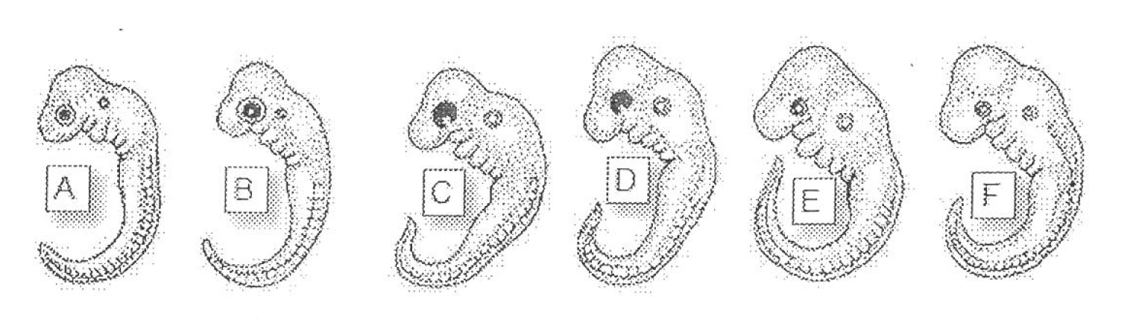

Hypothesise which embryo is from each of the following organisms and give a reason for your choice.

|  |  |  |
| --- | --- | --- |
| **Species** | **Embryo** | **Reason** |
| Human |  |  |
| Chicken |  |  |
| Rabbit |  |  |
| Tortoise |  |  |
| Salamander |  |  |
| Fish |  |  |

**These are older, more developed embryos from the same organisms.**

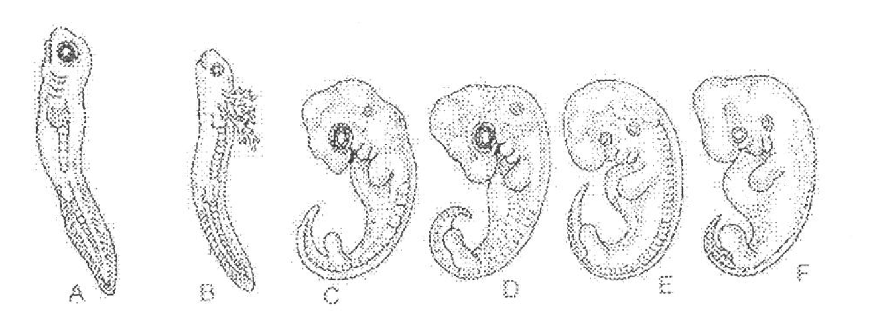

Hypothesise which embryo is from each of the following organisms and give a reason for your choice.

|  |  |  |
| --- | --- | --- |
| **Species** | **Embryo** | **Reason** |
| Human |  |  |
| Chicken |  |  |
| Rabbit |  |  |
| Tortoise |  |  |
| Salamander |  |  |
| Fish |  |  |

**These are the embryos at their most advanced stage, shortly before birth.**

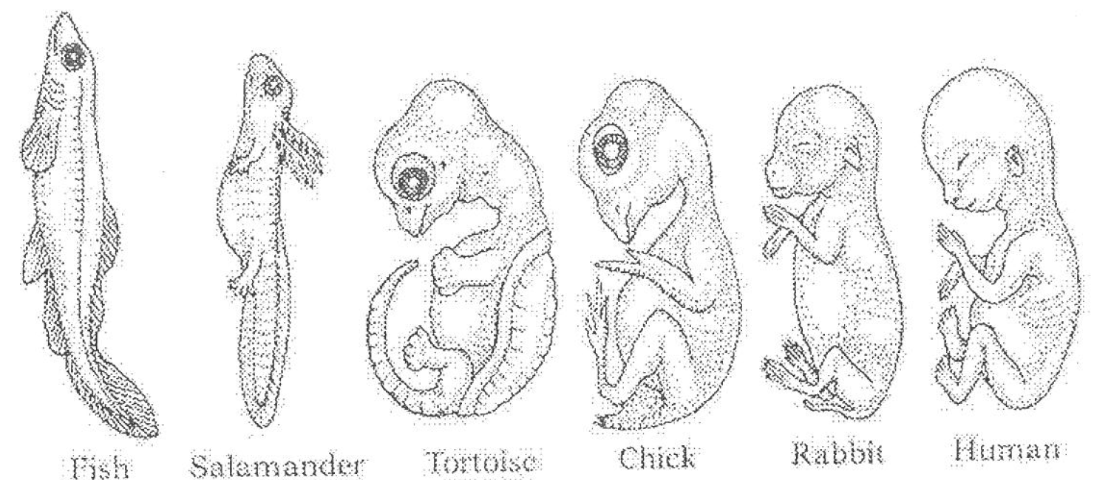

Describe how the embryos have changed for each of these organisms from their earliest stage to the latest stage.

|  |  |
| --- | --- |
| **Species** | **Anatomical changes From Early to Late Stages** |
| Human |  |
| Chicken |  |
| Rabbit |  |
| Tortoise |  |
| Salamander |  |
| Fish |  |

Look again at the embryos in their earliest stages. What physical similarities exist between each of the embryos?

Does this suggest an evolutionary relationship? Can these embryos be used as evidence of a common ancestor between each of these six organisms?

**Comparative Anatomy**

**Shown below are images of the skeletal structure of the front limbs of 6 animals: human, crocodile, whale, cat, bird and bat. Each animal has a similar set of bones.**

**Use the labelled human arm to colour code the different bones in each limb. Complete the key below.**

Humerus □ Carpals □

Ulna □ Metacarpals □

Radius □ Phalanges □

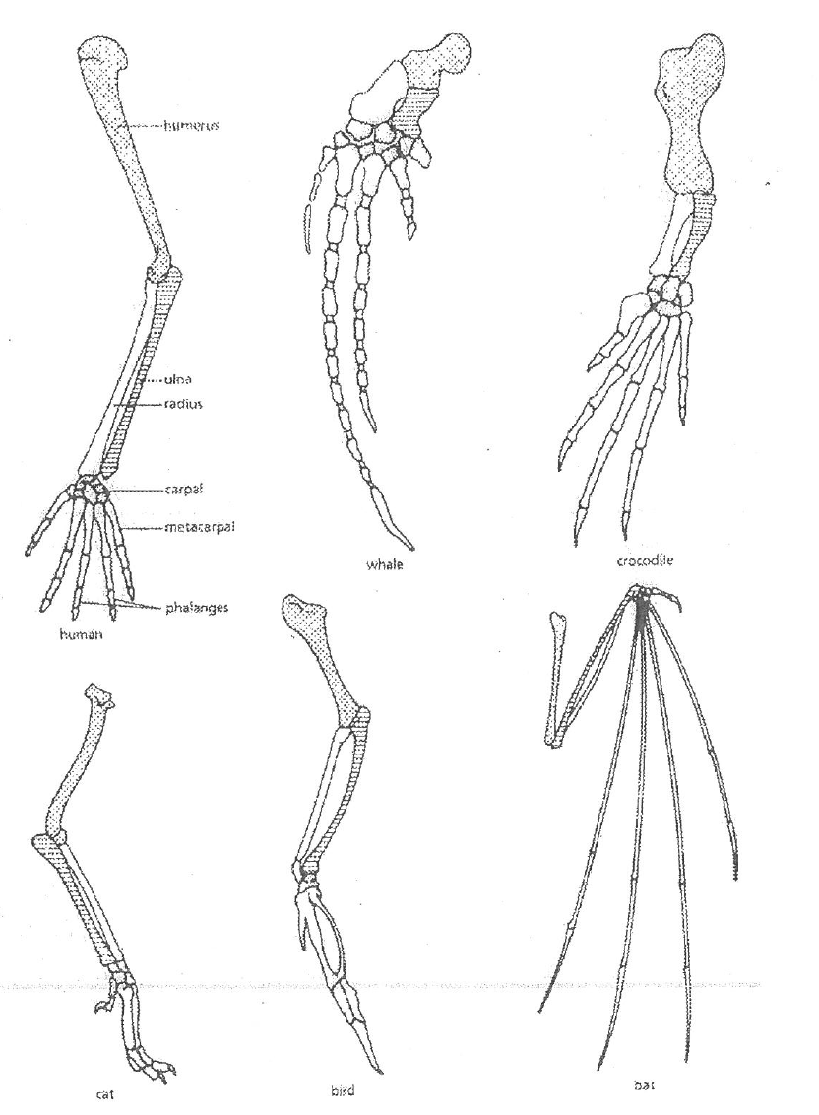

**For each animal, indicate what type of movement each limb is responsible for.**

|  |  |
| --- | --- |
| **Animal** | **Primary Functions** |
| Human | Using tools, picking up and holding objects |
| Whale |  |
| Crocodile |  |
| Cat |  |
| Bird |  |
| Bat |  |

**Compare the skeletal structure of each limb to the human arm. Relate the differences you see in *form* to the differences in *function*.**

|  |  |  |
| --- | --- | --- |
| **Animal** | **Comparison to human arm in form** | **Comparison to human arm in function** |
| Whale | Much shorter and thicker humerus, radius and ulna. Much longer metacarpals. Thumb has been shortened to a stub. | Whale fin needs to be longer to help movement through water. Thumbs not necessary as fins are not used for grasping. |
| Crocodile |  |  |
| Cat |  |  |
| Bird |  |  |
| Bat |  |  |

**Compare the anatomy of the butterfly and bird wing below.**

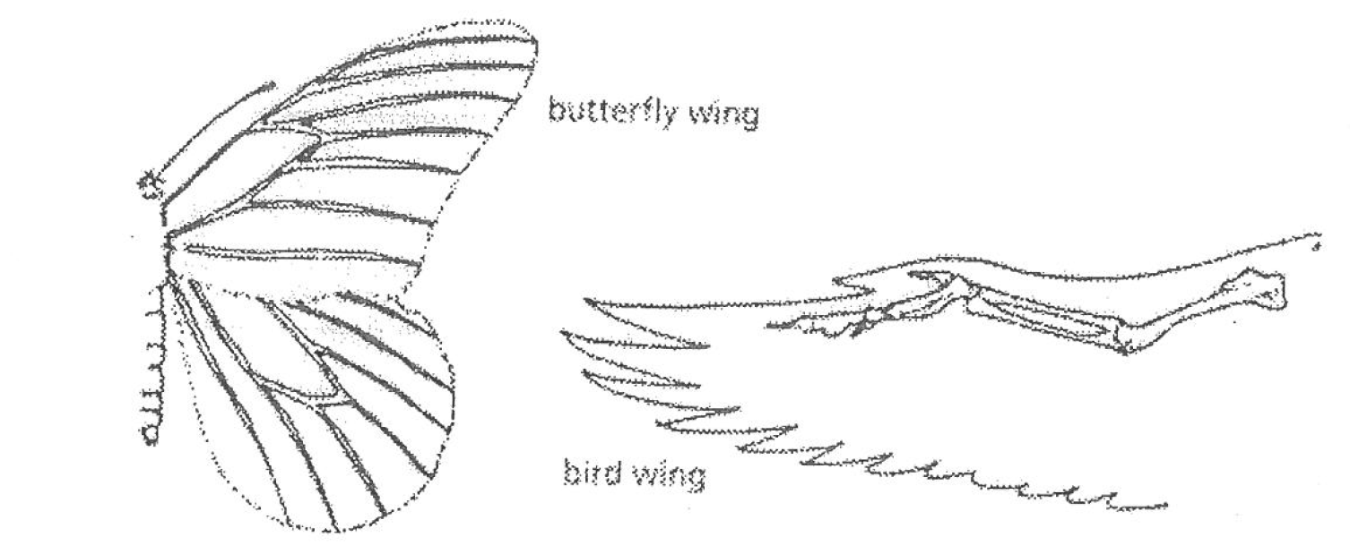

What is the function of each of these structures?

How are they different in form?

**Compare the body structure of the cave fish and the minnow below.**

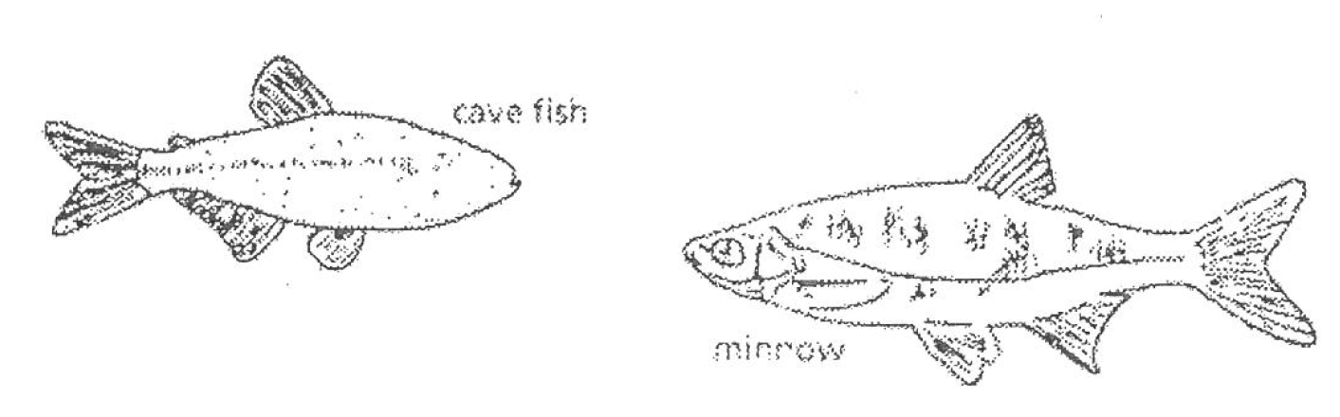

What is the most obvious difference between the body structures of the two fish?

Assume the fish came from the same ancestor. Why might the cave fish have evolved without eyes?

What kind of sensory adaptation would you hypothesise the cave fish to have to allow it to navigate in a cave and catch its food?

**Molecular Biology**

Cytochrome c is a protein found in mitochondria. It is used in the study of evolutionary relationships because most animals have this protein. Cytochrome c is made of 104 amino acids joined together. Below is a list of some of the amino acids in part of a Cytochrome c protein molecule for 9 different animals. Not all amino acids are shown.

For each non-human animal, take a highlighter and mark any amino acids that are different to the human sequence. When you finish record how many differences you found in the table on the next page.

|  |  |  |  |  |  |  |  |  |  |
| --- | --- | --- | --- | --- | --- | --- | --- | --- | --- |
|  | **Human** | **Chicken** | **Horse** | **Tuna** | **Frog** | **Shark** | **Turtle** | **Monkey** | **Rabbit** |
| **42** | Q | Q | Q | Q | Q | Q | Q | Q | Q |
| **43** | A | A | A | A | A | A | A | A | A |
| **44** | P | E | P | E | A | Q | E | P | V |
| **46** | Y | F | F | Y | F | F | F | Y | F |
| **47** | S | S | T | S | S | S | S | S | S |
| **49** | T | T | T | T | T | T | T | T | T |
| **50** | A | D | D | D | D | D | E | A | D |
| **53** | K | K | K | K | K | K | K | K | K |
| **54** | N | N | N | S | N | S | N | N | N |
| **55** | K | K | K | K | K | K | K | K | K |
| **56** | G | G | G | G | G | G | G | G | G |
| **57** | I | I | I | I | I | I | I | I | I |
| **58** | I | T | T | V | T | T | T | T | T |
| **60** | G | G | K | N | G | Q | G | G | G |
| **61** | E | E | E | N | E | Q | E | E | E |
| **62** | D | D | E | D | D | E | E | D | D |
| **63** | T | T | T | T | T | T | T | T | T |
| **64** | L | L | L | L | L | L | L | L | L |
| **65** | M | M | M | M | M | R | M | M | M |
| **66** | E | E | E | E | E | I | E | E | E |
| **100** | K | D | K | S | S | K | D | K | K |
| **101** | A | A | A | A | A | T | A | A | A |
| **102** | T | T | T | T | C | A | T | T | T |
| **103** | N | S | N | S | A | A | S | N | N |
| **104** | E | K | E | - | K | S | K | E | E |

|  |  |  |  |
| --- | --- | --- | --- |
| **Animal** | **No. of Amino Acids Different to Humans** | **Animal** | **No. of Amino Acids Different to Humans** |
| Horse |  | Shark |  |
| Chicken |  | Turtle |  |
| Tuna |  | Monkey |  |
| Frog |  | Rabbit |  |

Based on the Cytochrome c data, which animal is most closely related to humans?

Do any of the animals have the same number of differences from human Cytochrome c? In situations like this, how would you decide what is more closely related to humans?

**Conclusion**

Charles Darwin published his book *On the Origin of Species* in 1859. Of the different types of evidence that you have looked at, which do you think he relied upon the most? Give reasons for your answer.

Given the amount of research and evidence available, why is it still classified as a theory?